1. Main interfaces or classes of Hibernate  
   **Ans :** Configuration, **ServiceRegistry** (used to build sessionFactory with standard services like transaction, connection customization using provided metadata), SessionFactory, Session, Transaction
2. Explain **hbm2ddl.auto** setting in configuration  
   (https://stackoverflow.com/questions/438146/what-are-the-possible-values-of-the-hibernate-hbm2ddl-auto-configuration-and-wha)
3. What is **show_sql** property.
4. What are the ways to create ID in entity class.
5. What is difference between drop & truncate table.
6. Pagination using spring data. What is difference between page & slice?  
   (<https://dzone.com/articles/pagination-and-sorting-with-spring-data-jpa>)
7. Different ways of query creation in Hibernate  
   (<https://what-when-how.com/hibernate/advanced-query-options-hibernate/>)
8. Query, Criteria Query, Native Query, Named Query, Typed Query
9. Get Vs Load method difference  
   (<https://www.journaldev.com/3472/hibernate-session-get-vs-load-difference-with-examples>)
10. Save, SaveOrUpdate, Persist, Merge  
    (<https://www.journaldev.com/3481/hibernate-session-merge-vs-update-save-saveorupdate-persist-example>)
11. Difference between open session & get current session in hibernate?  
    (https://java2blog.com/difference-opensession-getcurrentsession-hibernate/)  
    - Open Session : Always opens new connection & we need to explicitly flush or close this session everytime.  
    - Get Current Session - It uses existing session if exists otherwise creates new session.
12. Why do we need transaction on read statements?  
    - If we don’t declare transaction then it will open session for each query whereas in case of transaction it uses one session for entire transaction boundary.
13. How can we initialize lazy load in detached object or Hibernate.initialize()?
14. How lazy load works internally & what is proxy object? (Proxy design pattern)
15. How @Cache works & what is CacheConcurrencyStrategy?  
    (https://docs.jboss.org/hibernate/orm/3.2/api/org/hibernate/cache/CacheConcurrencyStrategy.html)
16. What is orphanRemoval & what is cascade effect?
17. **What is isolation? (Dirty reads, Phantom Reads etc.)  
    Serializable, Repeatable Reads, Read Uncommitted, Read Committed.**(https://en.wikipedia.org/wiki/Isolation_%28database_systems%29#SERIALIZABLE)
18. How 1st level, 2nd level & query level caching works?
19. **Explain state changes of hibernate objects  
     Object not attached with any row (or new object) is Transient. Transient instances may be made persistent by calling save(), persist() or saveOrUpdate(). Persistent instances may be made transient by calling delete(). Any instance returned by a get() or load() method is persistent. Detached instances may be made persistent by calling update(), saveOrUpdate(), lock() or replicate(). The state of a transient or detached instance may also be made persistent as a new persistent instance by calling merge().**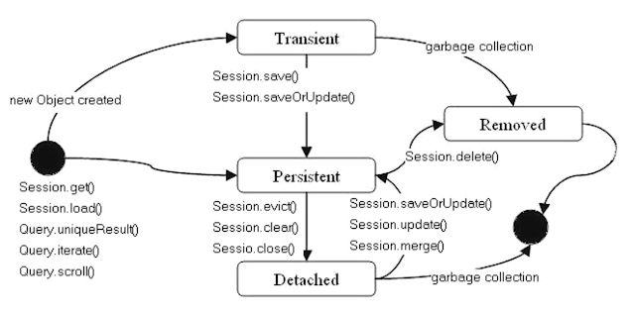
20. Session documentation  
    (https://docs.jboss.org/hibernate/orm/3.5/javadocs/org/hibernate/Session.html)
21. Hibernate upgrade lock mode explaination :  
    (https://stackoverflow.com/questions/21030740/hibernate-lockmodes-lockoptions)
22. Save() vs persist() vs saveOrUpdate()  
    (https://javarevisited.blogspot.com/2012/09/difference-hibernate-save-vs-persist-and-saveOrUpdate.html)
23. How to perform selective updates only rather than entire update query execution for all fields?  
    @**DynamicUpdate**

**Major annotations :**  
 @Table, @Entity, @Id, @Column, @Transient, @Embeddable, @OneToMany, ManyToOne, ManyToMany, OneToOne, @Cacheable, @Cache, @EmbeddedId, @PrimaryKeyJoinColumn

1. How can we create OneToOne, OneToMany, ManyToOne & ManyToMany relationship
2. What happens if we don’t use mappedBy parameter in OneToMany or ManyToOne or ManyToMany relationships.
3. How to do eager or lazy fetch?
4. What is left outer, right outer join?
5. What is primary & secondary caching? How it works & how can we configure?
6. How locking or synchronization works in hibernate?
7. Usage of **Hibernate.cache.use_second_level_cache & hibernate,cache.region.factor_class, hibernate.cache.use_query_cache** for second level cache.
8. Explain cacheConcurrencyStrategy
9. How to do hibernate caching for query
10. Different types of query creations in hibernate (criteria, native etc.).
11. What are the states hibernate object maintains?  
    **Ans :** Transient, persistent, removed, detached.
12. Optimistic & pessimistic locking
13. Database query Optimization :   
    (<https://www.toptal.com/sql-server/sql-database-tuning-for-developers>)  
    